Name : Zuha Irfan
Roll No : 2023-BSE-073
Subject: Cloud Computing
Semester & Section : V-B
Assignment 2 – Terraform & AWS Setup

Phase 1: Environment Setup

1.1 Install AWS CLI
Screenshot: aws_cli_install.png
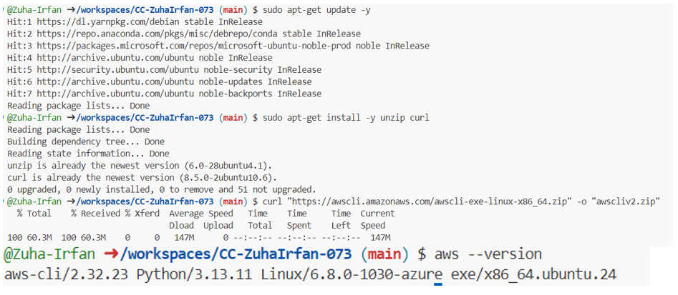

1.2 Configure AWS CLI
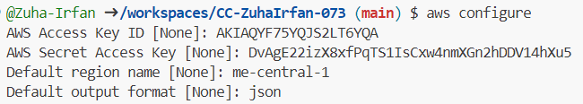
Screenshot: aws_configure.png

1.3 Install Terraform
Screenshot: terraform_install.png
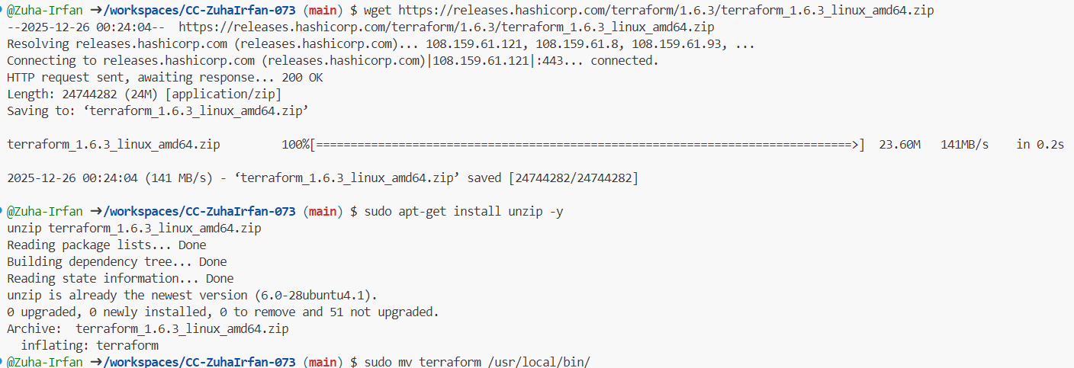

1.4 Verify Installations
Screenshot: verify_installation.png
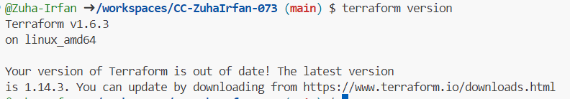

Phase 2: SSH Key Generation

21.Generate SSH Key Pair
Screenshot: ssh_keygen.png
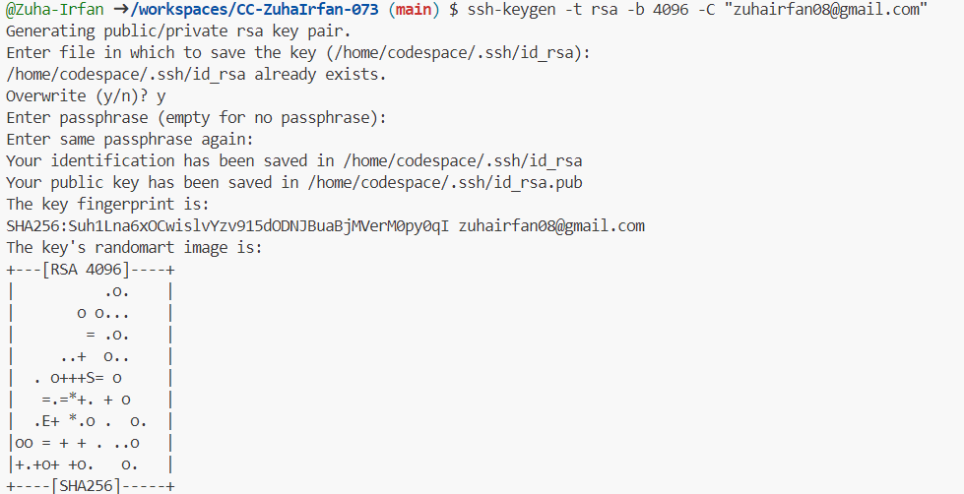

2.2 Verify SSH Keys
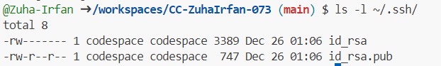
Screenshot: ssh_key_verify.png

Phase 3: Terraform Project Initialization

3.1 Create Project Directory
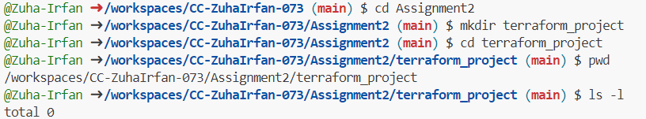
Screenshot: project_directory.png

3.2 Create Terraform Files
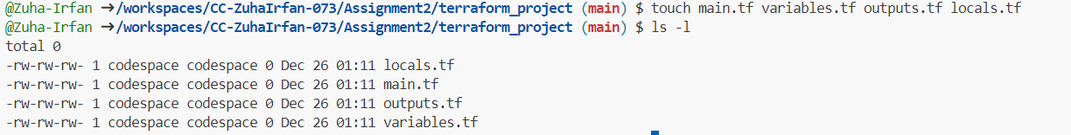
Screenshot: terraform_files.png

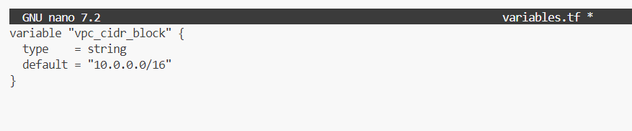
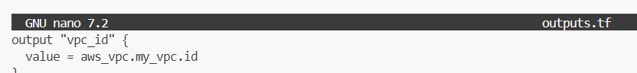

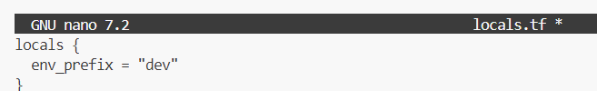
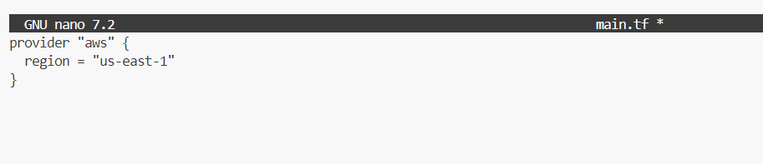

3.3 Initialize Terraform
Screenshot: terraform_init.png
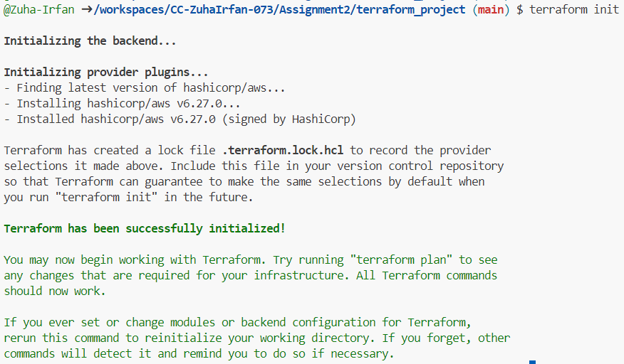

Phase 4: Terraform Resource Creation

4.1 Configure AWS VPC
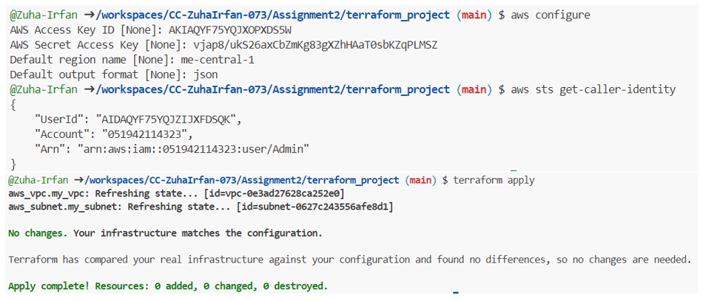
Screenshot: vpc_setup.png

4.2 Configure Subnet
Screenshot: subnet_setup.png
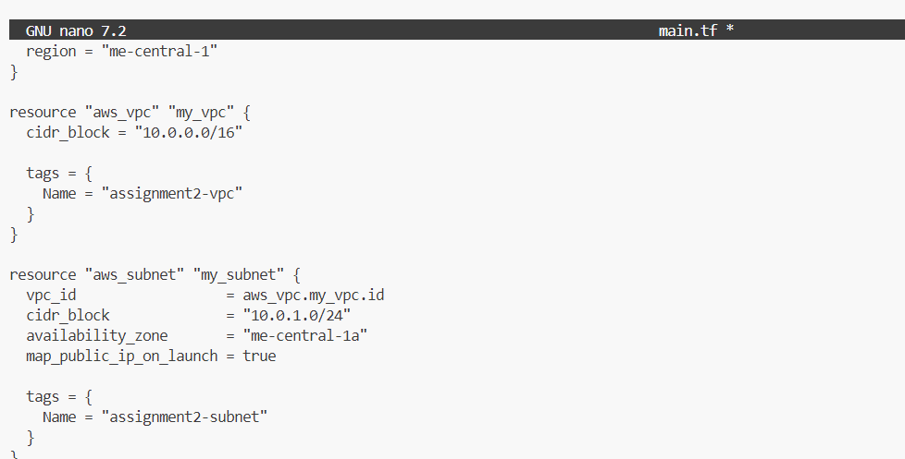

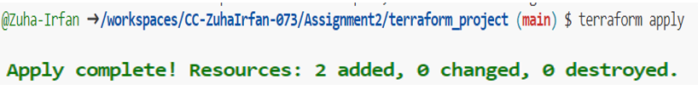

4.3 Configure Security Groups
Screenshot: security_group.png
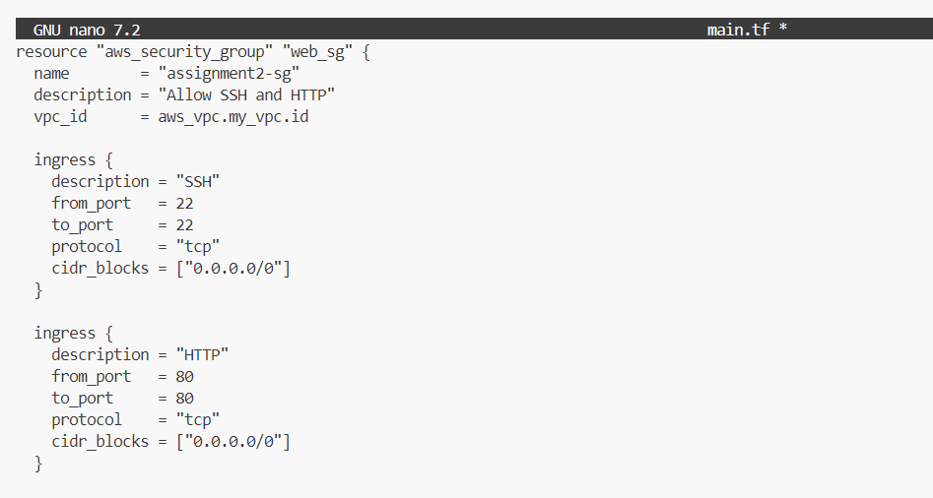

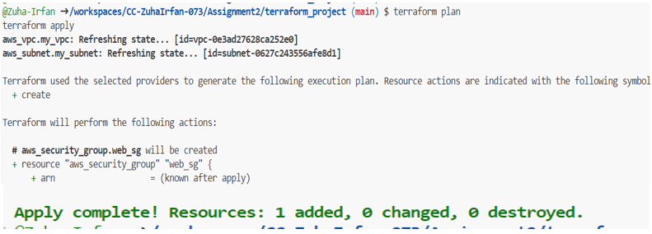

4.4 Configure EC2 Instance
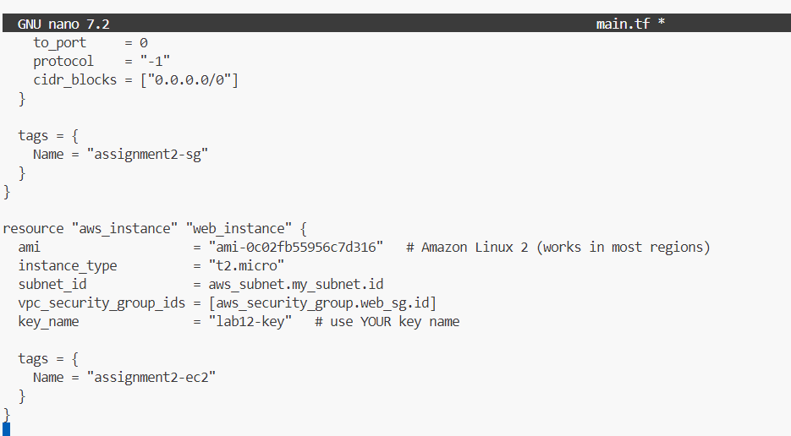
Screenshot: ec2_instance.png

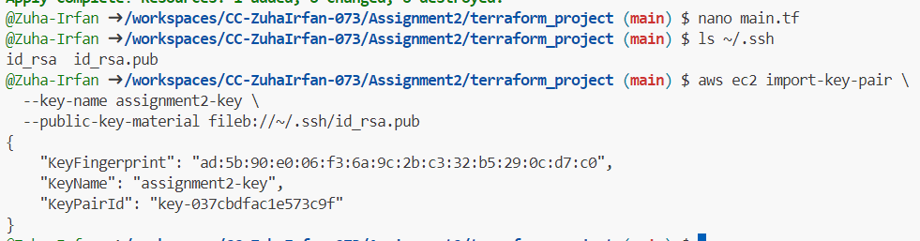

Screenshot: terraform_apply_ec2.png
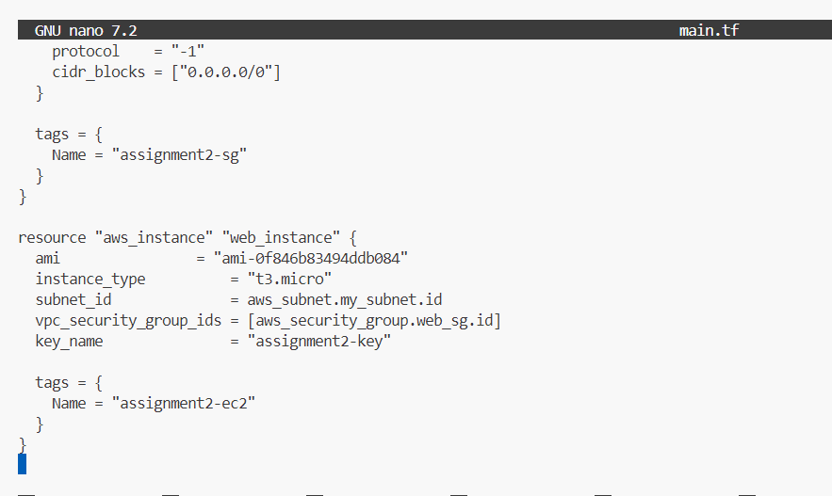

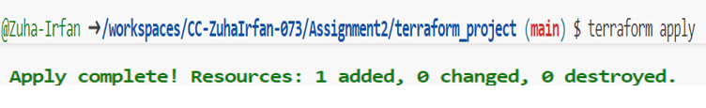

Phase 5: Remote Provisioning

5.1 Configure Remote-Exec Provisioner
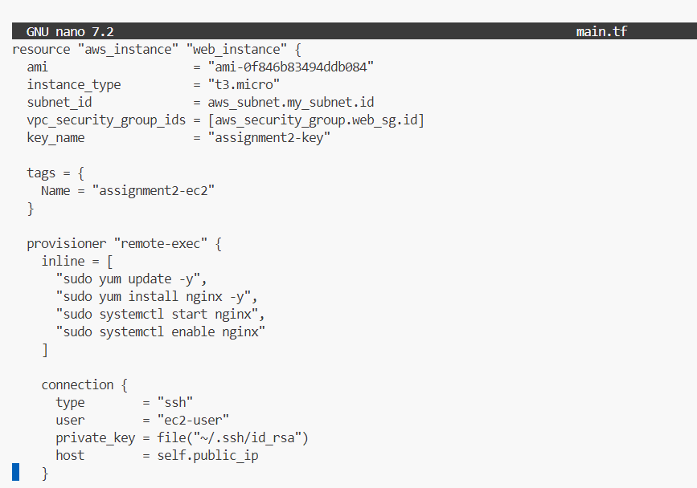
Screenshot: remote_exec.png

5.2 Apply Terraform Configuration
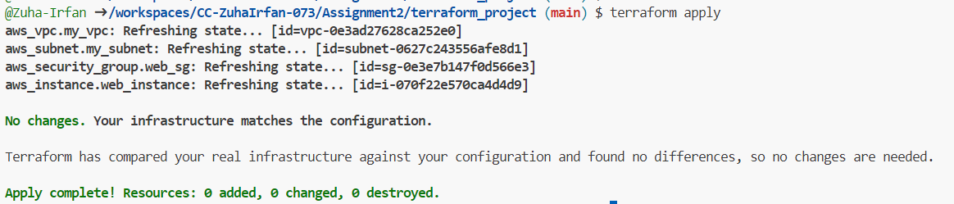
Screenshot: terraform_apply.png

5.3 Verify Resource Creation
Screenshot: terraform_output.png
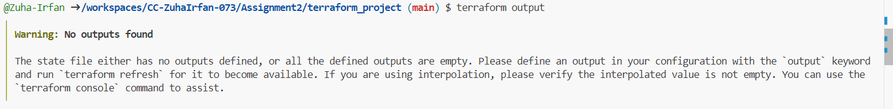

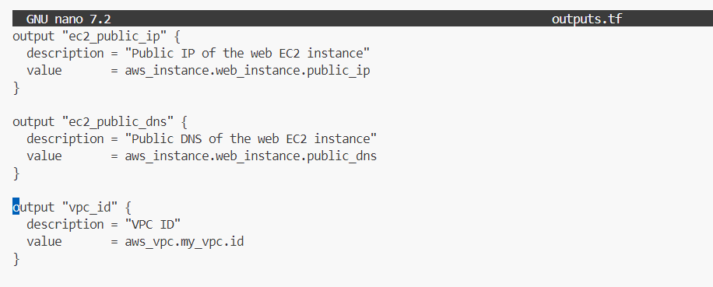

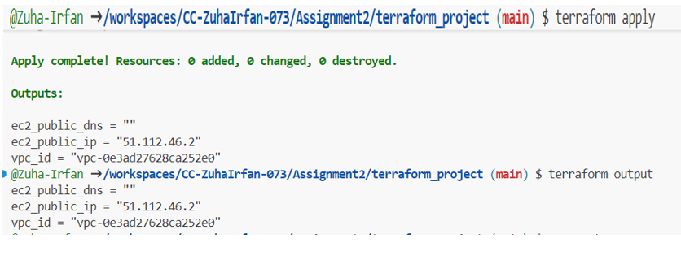

Screenshot: nginx_browser.png (if Nginx is installed)
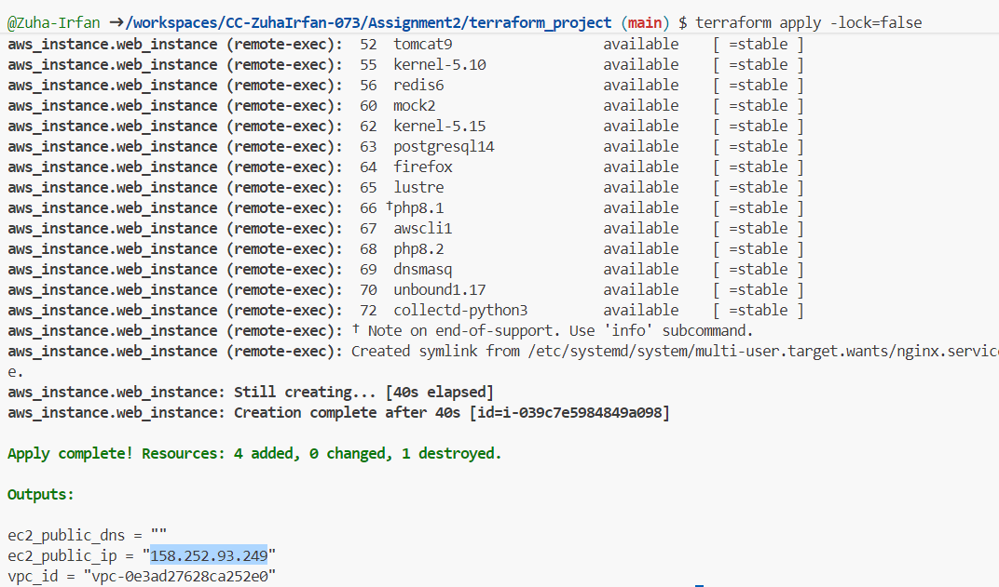

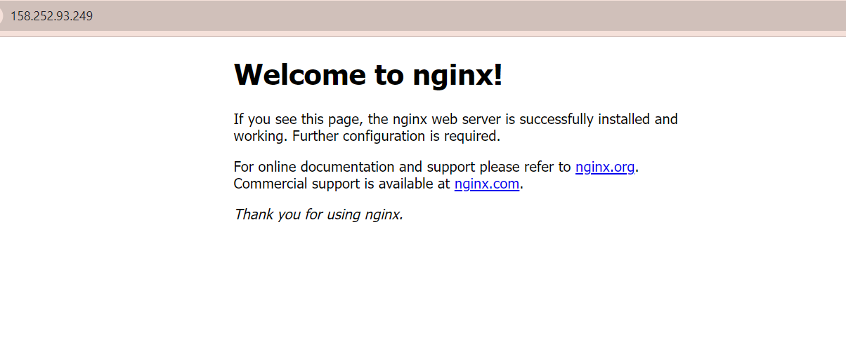

Phase 6: Cleanup Resource

6.1 Destroy Terraform Resources
Screenshot: terraform_destroy.png
